
Business to Manufacturing
Markup Language
Version 0401
B2MML Mapping Sheets



IMPORTANT: While the information, data, and standards provided in this publication were developed and are presented in good faith in accordance with a reasonable process that was subject to intellectual property and antitrust policies to benefit the industry as a whole, the publication is provided “as is” for information and guidance only, and there is no representation or warranty of any type or kind, including but not limited to warranties of merchantability or fitness for a particular purpose, and no warranty that use of the information, data, or standards will not infringe patent, copyright, trademark, trade secret, or other intellectual property rights of any party.

Contents
Mapping Sheets 3
Need for Mapping 3
Mapping Sheets 4
Mapping Sheet Structure 4
Adding Repeating Elements 8
Application Interface Types 9
Flat File Mapping 9
Database Interface Tables 11
Proprietary XML 12
Creating Additional Mapping Sheets 14

Change History:
Change | Date | Person | Description
V01 | 2009-08-21 | Dennis Brandl | Initial release

Mapping Sheets

This document documents mapping spreadsheets that can be used to define the mapping of application data to B2MML elements.

Need for Mapping
The B2MML schemas define the structure and format for exchanged data. It does not however define how the exchanged information is mapped into applications participating in the data exchange.
Unless a participating application provides a native B2MML interface, each application will need to copy data from their local data space or local interface into a B2MML document or from a B2MML document to their local interface. If the application does have a native B2MML interface there is still the need to define the local property names for exchanged elements.
The B2MML mapping sheets provide a method to document how the local application data elements map into a B2MML document.
The application data may be sourced from, or copied to, in several different formats:
- Flat File – The interface to/from the application is in a file, often a text file, with a fixed format that is located in a specific directory. Interface code would be written to take data from a B2MML document and create a flat file, or would be written to read a flat file and generate a B2MML document.
- Database Table – The interface to/from the application is in one or more database tables. These are often called staging tables, because they are specific tables build to hold (or stage) the data for use by the interface. Interface code would be written to take data from a B2MML document and write it to the staging tables, or would be written to read data from the staging tables and generate a B2MML document.
- Proprietary XML – The interface to/from the application in the applications proprietary interface. Either an application interface program or an ESB will convert between B2MML and the proprietary interface.
- Native B2MML – The application imports and exports in native B2MML format. Because of version differences an application interface program or an ESB may be required to convert B2MML versions.
Legacy applications will invariably have their local names for data elements. It is rare that these will line up across applications. For example one application may use the term “Product Code” while another application may use “Item Master Number”, with the data item stored in a MaterialDefinition/ID element. The B2MML mapping spreadsheets define the local names of the elements and where they reside in a B2MML document.

Mapping Sheets
The following mapping sheets are provided.
- MaterialDefinition Mapping Sheet
- MaterialClass Mapping Sheet
- ProductDefinition Mapping Sheet
- ProductionSchedule Mapping Sheet
- ProductionPerformance Mapping Sheet

Mapping Sheet Structure
The B2MML Mapping Sheets have the following structure:
- There is one sheet for each exchanged object. The sheets contain the name of the object (e.g. “B2MML Mapping Sheet – MaterialClass”).
- There is one tab on each sheet for each exchange message. The tabs follow the ISA 95 Part 5 standard for message types (Sync, Process, Get, Show, …)
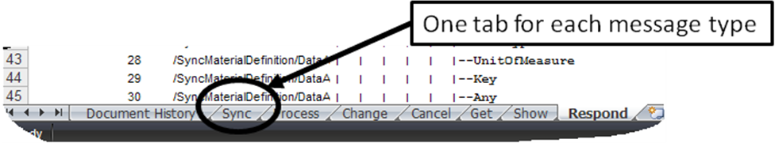
If separate messages are used for SYNC ADD, SYNC CHANGE, and SYNC DELET, then copy the SYNC worksheet and modify as necessary.
- Column “A” contains a formula that sets the cell to “Mapped” if there is any information in columns E through X and leaves the cell blank otherwise.
=IF(COUNTA(Exxx:Xxxx)>”0”,”Mapped”,”
This column can be used to filter the sheet to display only the mapped elements.
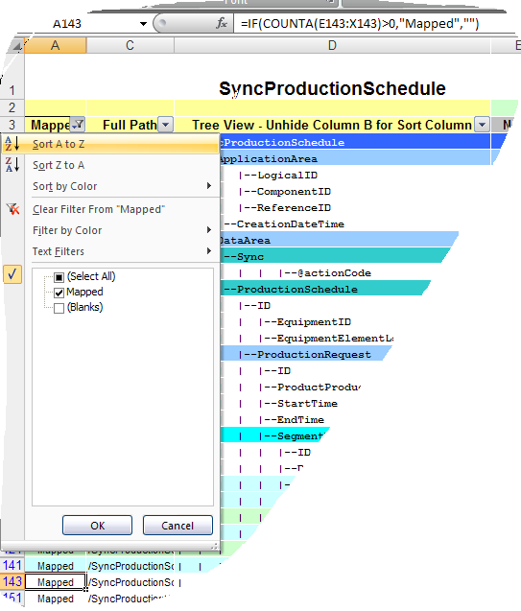
- Column “B” (normally hidden) contains the row number. This column must be manually updated when new rows are added. It can be used to reorder the sheet back to the correct row order in case you accidently sort the sheet. (The first three selections on the drop down menu are to sort the column and accidently selecting them will make the sheet not usable.)
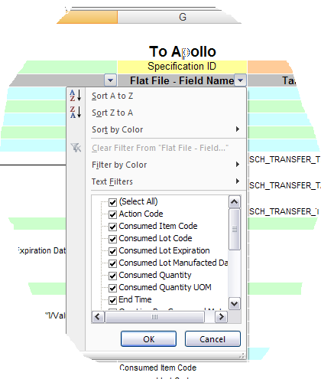
- Column “C” has the partial XPath of the B2MML element. The partial XPath does not contain the element identification required if there are multiple elements.

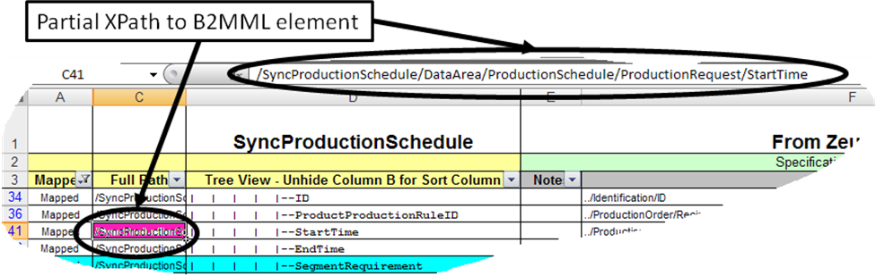
Note: A full XPath may contain one or more identifying values, such as:
/SyncProductionSchedule/DataArea/ProductionSchedule[1]/ProductionRequest[ID=’1’]/StartTime

- Column “D” contains a tree view of the B2MML document, with each nested element indented. Rows with elements that contain nested elements are colored, elements that contain values (leaf elements) are not colored. This makes it easier to quickly look at the document and find the leaf nodes.
- Columns E through X can contain the mapping to applications.
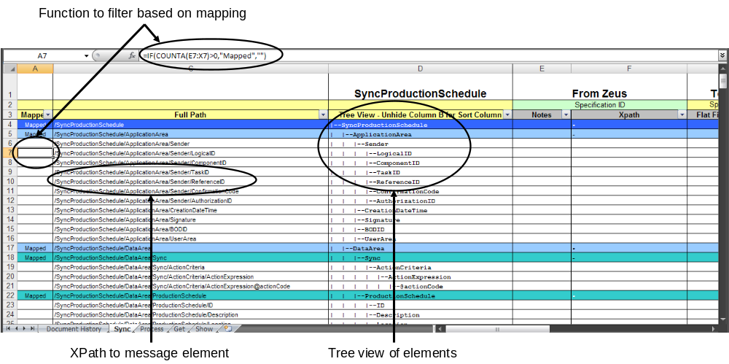
- One or more columns can be used for each mapped application. The spreadsheets use the made up names of “Zeus”, “Thor” and “Apollo” as the application names
- Each exchanged element is defined in one row.
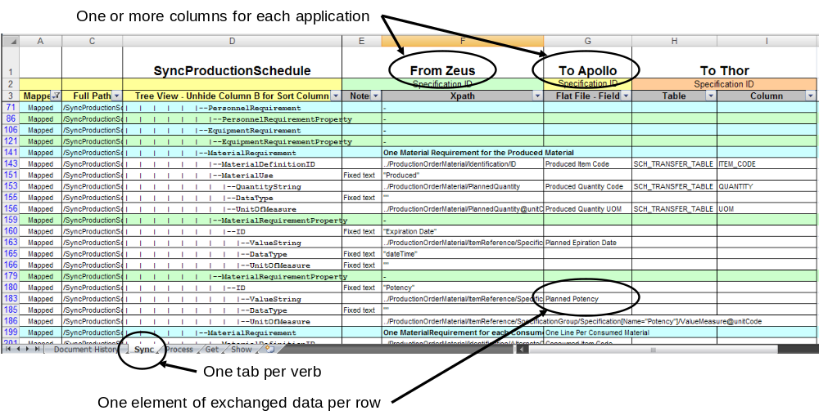

Adding Repeating Elements
Most of the B2MML schemas have many repeating elements (properties, segments, …). When copying repeating elements you will have to show all elements (not just the mapped elements). After copying the selected rows it is important to remember to update the row order numbers in column “B”.
The next figure shows all of the elements under a MaterialRequirementProperty. For each exchanged property copy the entire element definition and paste a new set of rows.
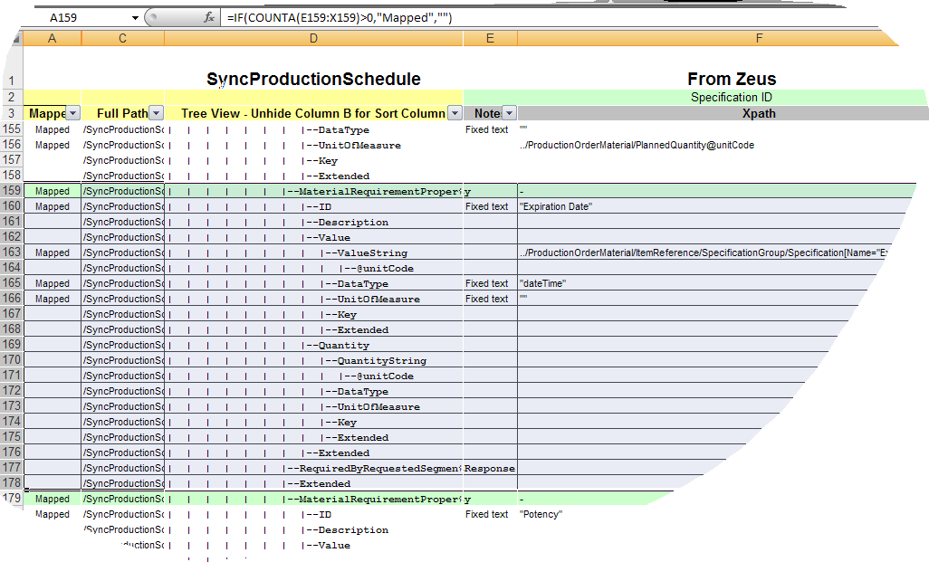

Application Interface Types

Flat File Mapping
Flat files will typically be ASCI files with fixed width columns. Interfaces are defined by specifying the source or destination column name and the source or destination of the data. Simple flat file interfaces will have names for the columns, as show below.
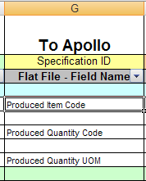
Many flat file systems will support multiple record types, with one column specifying the record type. In those cases multiple columns should be used to identify the record type and the field name for the record type, as shown in the next figure.
The multiplicity of elements can also be documented in the non-leaf rows. For example, in the figure below there is on “E3 BOM Item” record in the flat file for each MaterialRequirement element under a specific segment requirement.
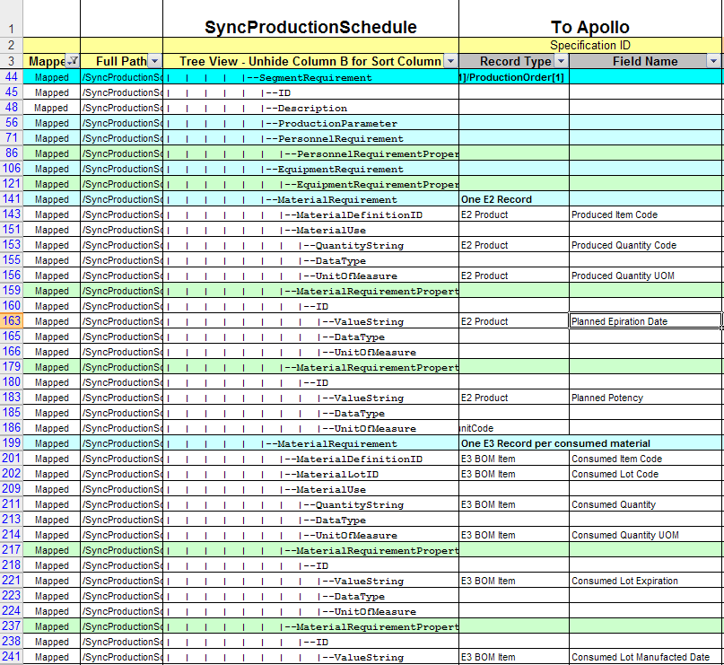

Database Interface Tables
Many legacy systems will have interface tables, sometimes called staging tables, which are used to exchange data with other applications. When using these interfaces with B2MML exchange documents the B2MML elements will map into specific tables and fields in the staging tables.
In this interface pattern there should be one column for the table name and one column for the table field. If the tables have a complex structure, or require a query to retrieve the data, then an additional column can be used to contain the select criteria, as shown in the next figure.
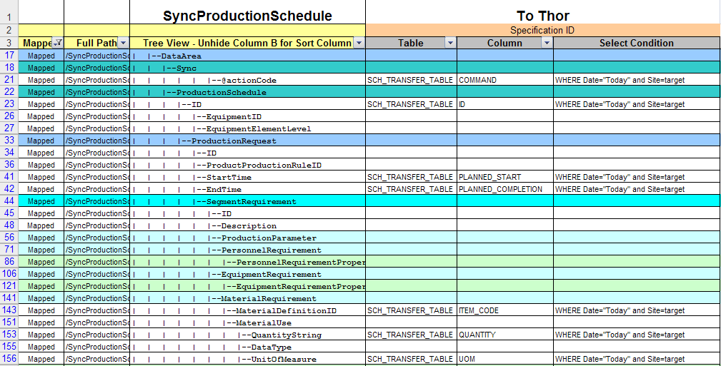

Proprietary XML
Many newer applications will have XML oriented interfaces, using SOAP or web services. In these cases the mapping from and to B2MML can use XPath specifications to define exactly where data elements are defined.
A typical XPath, also shown in line F163 in the figure below, is:
../ProductionOrderMaterial/ItemReference/SpecificationGroup/Specification[Name="Expiration Date"]/ValueDate
The application’s XPath should have the full XPath specification in order to reduce interface confusion.

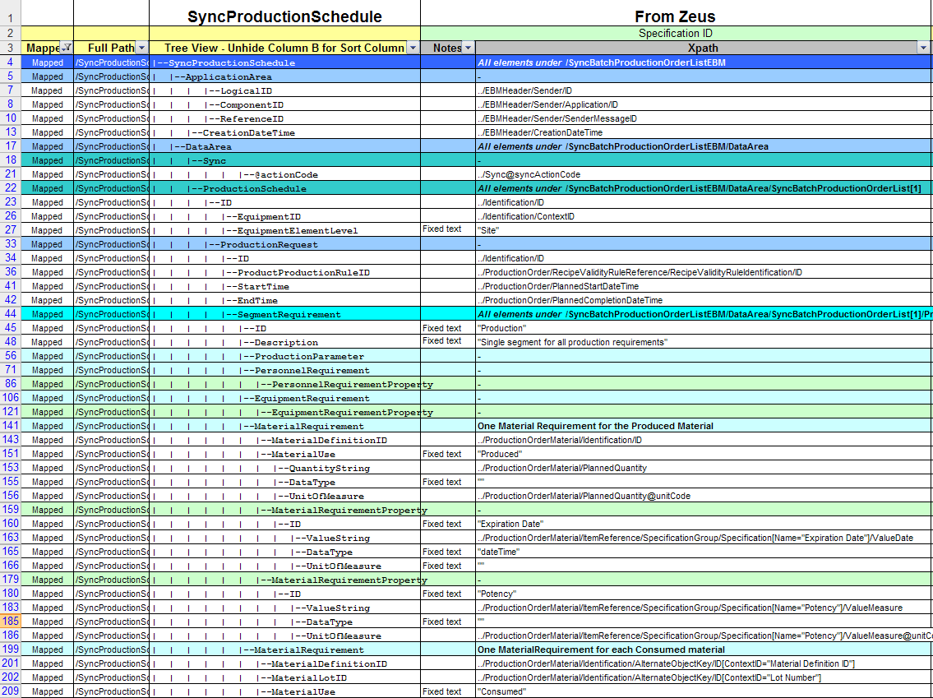

In XML to XML transfers it is important to specify the multiplicity mapping and full XPath. Because XPaths can be very long it may be useful to define the leading XPath elements in the non-leaf rows. This is shown in the figure below.

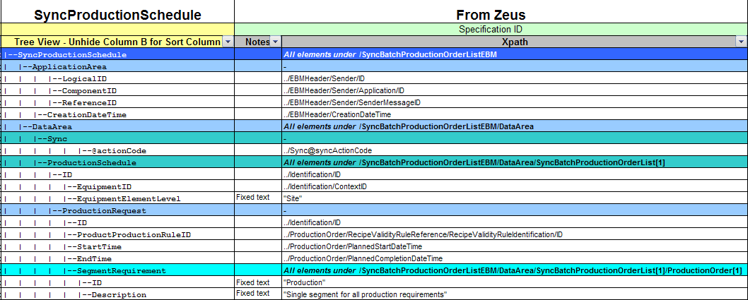

Creating Additional Mapping Sheets
If you need mapping sheets for different objects the following
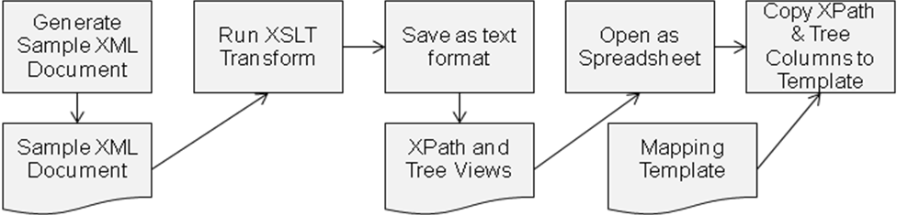
The XSLT file, B2MML-XSLTto xpath tree of XML Doc.xslt , is included with the mapping sheets. This XSLT will convert a sample XML document into its XPath elements and into the tree format view. This file can be pasted into the mapping template document, B2MML-Mapping Sheet-Template-Full.xls.
The XSLT transform will work on any XML file and is not restricted to B2MML files.
<?xml version="1.0"?>
<xsl:stylesheet xmlns:xsl="http://www.w3.org/1999/XSL/Transform" version="1.0">
<xsl:template match="/">
<xsl:value-of select="'&#x0A;'" />
<xsl:apply-templates select="node()" />
</xsl:template>

<xsl:template match="node()" priority="1" >
<xsl:param name="parent-XPath" />
<xsl:param name="parent-ShortPath"/>
<xsl:param name="parent-LocalPath"/>
<xsl:variable name="current-XPath" select="concat($parent-XPath, '/', name())" />
<xsl:variable name="current-LocalPath" select="concat($parent-LocalPath, '/', local-name())" />
<xsl:value-of select="concat($current-LocalPath,'&#x09;', $parent-ShortPath, '|--', local-name(), '&#x0A;')" />
<xsl:variable name="current-ShortPath" select="concat($parent-ShortPath, '| ')" />
<xsl:if test="boolean(node() | @*)">
<xsl:apply-templates select="node() | @*">
<xsl:with-param name="parent-XPath" select="$current-XPath" />
<xsl:with-param name="parent-ShortPath" select="$current-ShortPath" />
<xsl:with-param name="parent-LocalPath" select="$current-LocalPath" />
</xsl:apply-templates>
</xsl:if>
</xsl:template>

<xsl:template match="@*">
<xsl:param name="parent-XPath" />
<xsl:param name="parent-ShortPath"/>
<xsl:param name="parent-LocalPath"/>
<xsl:if test="name()='actionCode' or name()='acknowledgeCode'">
<xsl:value-of select="concat($parent-LocalPath,'@',local-name(),'&#x09;', $parent-ShortPath, '|--@', local-name(), ' &#x0A;')" />
</xsl:if>
</xsl:template>

<xsl:template match="text()" priority="2">
<xsl:param name="parent-XPath" />
</xsl:template>

<xsl:template match="comment()" priority="2">
<xsl:param name="parent-XPath" />
</xsl:template>

<xsl:template match="processing-instruction()" priority="2">
<xsl:param name="parent-XPath" />
</xsl:template>

</xsl:stylesheet>

